Getting Garbed: A Very Basic Guide for Newcomers
Some people come to their first event already knowing exactly who they want to be, what they want to look like, and how to achieve that look. The rest of us must do some research and ask for help. Here are my first few tips!
1) Give yourself time to explore the SCA before creating your persona and your garb. Investigate all the options and see what you like!
2) Talk to people. Anyone you see in cool garb will be happy to talk to you about it. That is a great way to learn about different styles and options.
The first few events you attend, you can borrow some garb to wear from the Gold Key or Loaner Garb. Most groups maintain a few general pieces that can be loaned out. After a few events though, you will want something of your own, even if you are not quite sure what you want to look like. The rules of the game are to “make an attempt at medieval garb”. That gives you quite a lot of leeway. I suggest start out making or buying a couple of generic starter pieces that will get you going.

Tunic:
Both men and women can wear a t-tunic and pants with some sort of leather or cloth shoe. Linen is a great all-purpose fabric but cotton works as well if you are on a budget. Here are some great examples of basic tunic styles (from Pinterest).
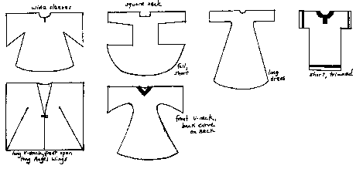
Combining a t-tunic with some loose long pants and a belt makes a nice, generic medieval look.
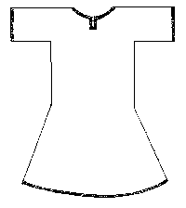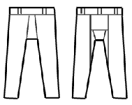
You can experiment with different kinds of fabrics and accessories to make the look simple or fancy. The basics however are the tunic, loose pants, and a plain shoe or boot. As for accessories, it is always nice to have a leather ring belt and a pouch to carry stuff in as well.
This is a nice link on a T-Tunic class for those willing to try making one: http://www.anastacias.com/garb_class.htm
Dresses:
Women can also wear an A-line dress with a belt or the A-line dress with a sideless surcoat for a good generic medieval look.
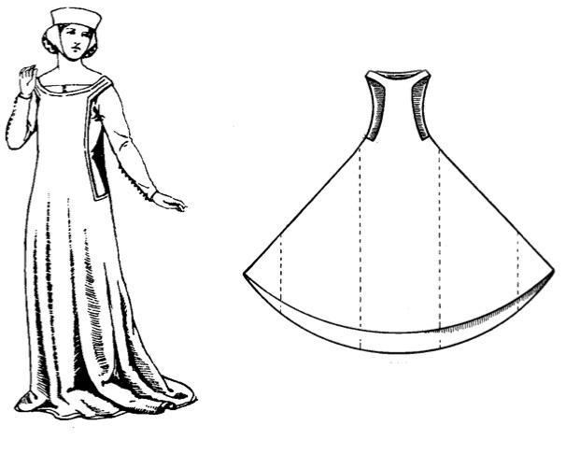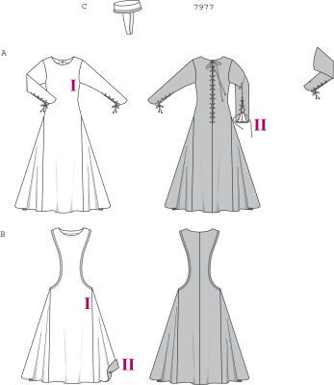
Here is a basic pattern for an underdress and sideless surcote:
Underdress: https://rosaliegilbert.com/tutorial_laced.html
Surcote: https://rosaliegilbert.com/tutorial_ssurcote.html

Shoes:
Keep it plain with no logos or brands visible. Standard options are knee high leather boots, Mary Janes, flats, or simple sandals. You will see folks wearing sneakers or orthopedic shoes – so if you have a health problem or concern, wear the shoes you need to wear. We understand the realities of bad knees and such and make allowances for common sense. We do a lot of walking at events, make sure your shoes are comfortable and fit you well.

Head coverings:
Men – this depends on your persona and local. Wide brimmed leather, felt, or straw hats are popular for keeping the sun out and you will see those everywhere. There are also small felt caps, turbans, and hoods available for men to wear.

Women – most medieval cultures expected women to cover their heads. Some women do not, it makes them uncomfortable and that is ok. If you want to complete your look though, a covering does make it look “right”. Simple veils and snoods are all very popular and acceptable. You will see some ladies in very fancy hats and those look amazing, but for your entry into the society, I suggest keeping it simple. Again, if you spot someone who looks great, stop and ask them about it. They will be tickled and be happy to tell you more about their garb.
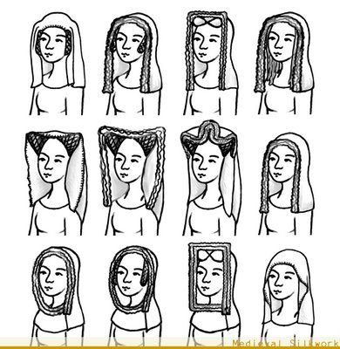 (Some examples of 14th century veil looks)

Sewing:
If you already know how to sew or are willing to learn, you are lucky. There are people in the SCA who love to teach that skill and will be happy to help you. Ask around your local group and they will help you find someone. If you already know how to sew, there are several pre-made patterns that you can use to make some good beginner pieces. Here are some sources for patterns (in no particular order):
Reconstruction History: https://reconstructinghistory.com/
Patterns of Time: https://www.patternsoftime.com/pattern-eras.php
Amazon Dry Goods: http://www.amazondrygoods.com/categories/historic-patterns/by-era/medieval.html
Folkwear: https://www.folkwear.com/collections/ethnic

Please note that Butterick, Simplicity and McCalls all have decent historic costume patterns that will also work.

There are also tons of patterns online. You can search for them by using terms like tunic, chemise, sideless surcoat, 10 gore, or cotehardie. Also google Viking tunic patterns, Viking underdress patterns, and Viking apron dress patterns for some nice easy to create garb. Here are just a couple of the many out there:

This is a nice overview of basic garb, fabrics, and patterns:
http://thehoodedhare.com/clothing_intro.htm

This is Lady Violet Ruthaven’s page on improving your garb:
http://www.trystancraft.com/costume/2011/05/04/newbie-garb-that-doesnt-look-newbie/

This is a web page for Lochac (an SCA group). It is a nice links page for basic garb help:
http://stursula.lochac.sca.org/files/2013/05/Garb-List-Chron.pdf

Purchasing:
Even if you cannot sew, it is relatively easy to get a few basic pieces. You can now buy many items for the SCA from SCA based merchants or LARP based merchants. Some merchants attend events and you will be able to shop there. If you cannot get to an event, you can shop online. While most companies are reputable, please be careful (as you always should be) when shopping online.

Here are a couple that have a good reputation:
Historical Enterprises: https://www.historicenterprises.com/
Revival Clothing: http://www.revivalclothing.com/
Garb the World: http://www.garbtheworld.com/pgs/sca.shtml
Linen Garb.com: https://www.linengarb.com/

Also check out your local shops, you never know when you will see something that looks about right. Pirate shirts or poet shirts come in and out of style pretty frequently and can work in a pinch. For pants, you can always start out with a loose, cotton, pajama pant that ties at the waist. I would suggest black. If you tuck those into boots, they blend very well.

Then as you attend events, meetings, arts and science nights, you can talk to people about styles, patterns, merchants, etc. and even commission some garb if you need to. Never forget that your local group is a great sounding board for garb ideas.

Remember – garb (and persona creation) is a process. You can constantly find new styles and ideas that attract you. So start slow and work up the fancy items. Most of all, have fun!!

